#### 

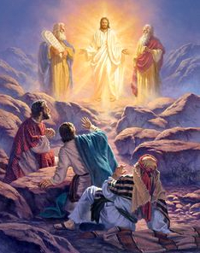

March 16th, 2025

2nd Sunday of

Lent

**Pastor:** Fr. Henry Smolenaars

**Fr. Henry Email:** frhenrys@gmail.com

**Hospital Chaplain**:  Fr. Wieslaw Papuga

**Priest on Call:** 902-746-8233 (Emergencies

and Sacrament of the sick)

**Office hours:** Monday to Friday

from 9:30 am to 1:00 pm

**Church email :** stambrosemail@gmail.com

**Bulletin email:** stambrosebulletin1@gmail.com

**Tabitha Centre:** 902-742-8960

**Confession/Adoration** Wednesday 7:00-8:00

**MASS INTENTIONS - March 15th – 23rd, 2025**

**St. Ambrose Co-Cathedral (Yarmouth):**

**Sat. 4 pm** Eva Deveau

**Sun.** **9am** **Parishioners**

**Sun. 11:15am** Coady Saulnier

**Tues. 6:30 pm** Intentions of Emma Muise

**Wed. 6:30 pm** William Letteney

**Thurs: 9 am** Ernie Doucette

**Fri. 9 am** Special Intentions

**Sat. 4 pm** Anniv. Edward Robicheau

**Sun.** **9am** Stella & Albert Cunningham

**Sun. 11:15am Parishioners**

**Our Lady of Lourdes (Melbourne):**

**Sun. 10 am Mar. 16** Oscar Harris

**Sun. 10 am Mar. 23** Robert Doucette

### Image result for free clipart on reflectionREFLECTION*:* Becoming “Fully Awake” Peter and his companions had been overcome by sleep, but becoming fully awake, they saw his glory and the two men standing with him. As they were about to part from him, Peter said to Jesus, “Master, it is good that we are here; let us make three tents, one for you, one for Moses, and one for Elijah.” But he did not know what he was saying.  As we are presented with this glorious event of the Transfiguration this Sunday, there are numerous lessons we can learn from it. The passage above presents us with two particular lessons.  First, Peter and his companions were overcome by sleep while Jesus was transfigured in glory and conversing with Moses and Elijah. This line could suggest many things. It could mean that Peter was weak and more concerned with his human condition than he was with attentiveness to the important journey he was invited to take with our Lord. It could reveal a kind of spiritual sloth. It is easy in life to become weary of the journey and to become drowsy at the times that we should be most attentive to our Lord. For example, think about any time when you knew you should pray but instead, sat daydreaming or distracted, or chose to fill that time with something mindless. Peter and his companions, therefore, teach us that it is easy for us in our fallen human nature to “doze off” during those times when God wants to speak to us, especially while at Mass. Another interpretation of this line comes from the Church Father, Saint Ambrose. He suggests that this sleep of Peter and his two companions was primarily a result of them encountering “the incomprehensible brightness of the Divine nature.” As Jesus was transfigured, the initial vision was too much for them to comprehend, and so this vision began with them asleep as a symbol of the fact that we are all incapable of seeing the glory of God in our weakened state. But then they became “fully awake,” which implies that it took time for them to open their eyes to see the glory of God. This lesson teaches us that we all must wake up and work to become fully awake if we are to see the glory of God as He reveals Himself to us. After becoming fully awake and encountering the incomprehensible brightness of the divine nature, Peter says, “Master, it is good that we are here; let us make three tents, one for you, one for Moses, and one for Elijah.” The Gospel writer then goes on to say that Peter “did not know what he was saying.” Again, if we turn to Saint Ambrose, he points out that Peter’s experience is commendable because he not only had earnest feelings but also took the initiative of good deeds. He wanted to build three tents so that Jesus, Moses and Elijah would remain with them. But another Church father points out that Peter “did not know what he was saying” because he did not, at that time, realize that it was indeed his mission to build a dwelling place for Jesus, the Law and the Prophets. It was his mission to build the Church, which was to be the future dwelling place of God on earth and the place in which we will encounter God throughout life. You, too, are entrusted with the responsibility of building up the structure of the Church on earth so that many may encounter the full glory of God. This will only happen if you continually seek to become fully awakened to the glory of God as He reveals Himself to you and, in the joy of that encounter, go forth to build up God’s Church by your earnest desire and intentional acts of charity. Reflect, today, upon Peter and his two companions, James and John. Prayerfully ponder them asleep as Jesus was transfigured in glory. Reflect upon them waking up and beginning to realize what was taking place before them. Consider Peter’s excitement and amazement and the effect that had on him. And then ponder how these disciples eventually did go forth to build the Church, the house of God, so that they and many others would come to meet Christ. Pray that the witness of these disciples will inspire you to follow in their footsteps. *My Transfigured Lord, the glory that shone forth from Your divine face in radiance must have been beyond human description. Your true glory in Heaven is something that I hope to one day behold. Please instill in me a desire to more fully understand Your glory and to work tirelessly to be an instrument of that glory to all I meet. Jesus, I trust in You.* -My Catholic Life

**COFFEE SOCIALS:** Will be held after all the masses this weekend March 15th & 16th in the Jubilee room. Please join us for a cup.

**FISH CHOWDER FRIDAYS:** We will be offering take out fish chowder on the Fridays of Lent. We ask you to call the parish office to place your order. The cost is $7.00 and it may be picked up at the Marian Hall doors between 4:00 and 5:00. Thank you for supporting our youth!

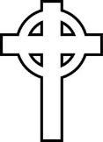

Our sympathy is extended to the family and friends of

Evelyn Nickey Muise and Florence Mae Harris

Eternal rest grant unto them O Lord and let perpetual light shine upon them.

**THIS WEEK'S EPISODE FROM THE SERIES *ETERNAL LIFE:***  *The Afterlife - What happens after the moment of our death? Once the soul has been separated from the body, then what? What is heaven, hell, and purgatory? What is the difference between the particular judgment and the general judgment? This session looks at the truth about what awaits the human person on the other side of death.* Come join us this Thursday night at 6:30 in the Jubilee Room.  P.S. If you haven't attended previous sessions, that's OK.  Fr. Henry

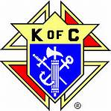**KNIGHT OF COLUMBUS NEWS**: **Community Breakfast:** This month’s Community Breakfast will be held at the Knights of Columbus Hall from 9:00 am to 12:00 pm March 23rd.  Everyone is welcome! The cost is $10.00 for adults and $7.00 for 12 and under. We appreciate your support!

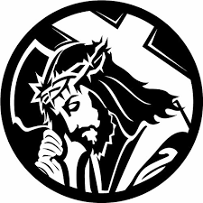**STATIONS OF THE CROSS** will be held on the Fridays of Lent at St. Ambrose Co-Cathedral at 6:30pm. Each week will be led by a different group.

**QUOTE OF THE WEEK:** Can there be a more fitting persuit in youth or a more valuable possession in old age than a knowledge of sacred scripture? In the midst of storms it will preserve you from the dangers of shipwreck and guide you to the shore of an enchanting paradise and the everlasting bliss of the angels. -St. Boniface

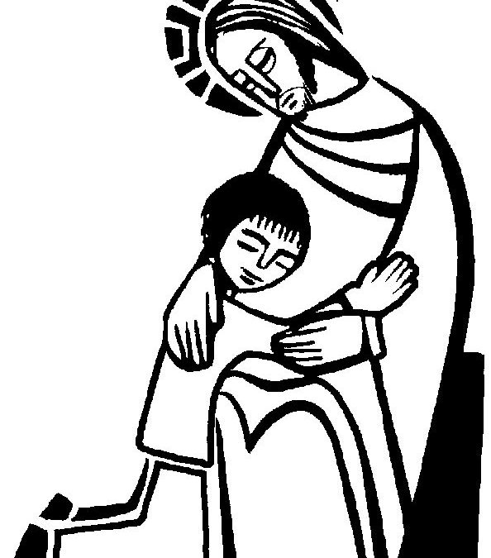**RECONCILIATION SERVICE:** There will be a reconciliation service **Wednesday April 2nd at 6:30 pm** here at St. Ambrose. Why not make this Easter extra special with feeling the deep forgiveness this sacrament can give? Please note that the Wednesday evening Mass will take place at 9am in the morning.