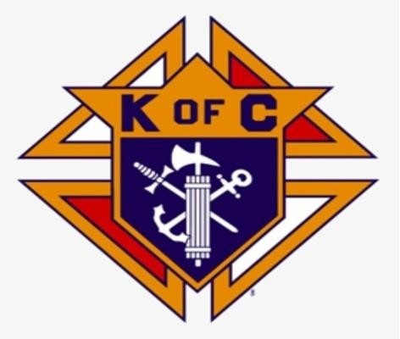Knightly News

# Council 2181

# SEPTEMBER 2024

**Grand Knight Roland LeBlanc**

The Knights of Columbus Council 2181 now serves the parishes of St Ambrose and Notre-Dame de L’ Assomption.

**Message from Grand Knight – Roland LeBlanc**

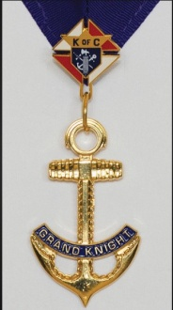Summer is slowly winding down, daylight hours are becoming less and there is cool crisp breeze as we finally approach fall. Schools, Colleges and Universities are opened after a summer break and students, teachers, and school administration staffs of all levels return to the classroom, we should ask the Holy Spirit to guide them and God to bless them as they experience all the excitement and anxieties of a new school year.

Council 2181 has been busy with its own work and services to the Christian Community and our church. Let us not forget the less fortunate and homeless and keep them in our prayers.

**Youth Summer Camp Golf Tournament**

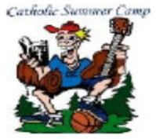Council 2181 will hold their annual Golf Tournament October 10th with a shotgun start at 10am. The cost is $40 person which includes golf and a meal. All proceeds are in support of the St. Ambrose Youth Summer Camp. Last year’s tournament funded a donation of $3000 made in June to help with costs so kids could attend the camp. This tournament is open to all. For more details please contact Phil Mooney (902-749-6379).

# Yarmouth Food Bank Support

Knights of Columbus are committed to helping end hunger through various programs – Council 2181 does this through our monthly food collection drive.

Members of our council are at the church on the first Sunday of every month before Masses, A total of $7000.00 and 650 lbs. of food was handed over to the Food Bank for the period of July, August and September 2024. We thank all our parishioners for their kind generosity and support to this worthy cause.

# Pro-Life Tri-County Care Centre Support

Submitted by Bill Carroll Council 2181 Chairman Pro-Life

The Pro-Life project started Mother’s Day weekend, May 12, and concluded on June 30, 2024. Our annual baby bottle fundraiser was extremely successful. A special thanks to all the brother knights who assisted in this worthy project. A huge thank you to all the Parishioners of St. Ambrose, Notre Dame l’Assomption for their much-appreciated support. The most notable contribution was the effort of 9-year-old Skylar Colli who was able to raise money from a lemonade and cookie stand with the support of her family. Thank you to the Colli family. Thank you to everyone who participated and for their generosity during this fundraising effort.

The breakdown of the bottles and money collected were as follows:

- St.Ambrose Co-Cathedral raised $4295.83

- Notre-Dame l‘Assomption raised $1667.81

- West Pubnico raised $651.15

- East Pubnico raised $346.45

- Skylar Colli raised $420.

**Operation Smile**

# Christmas clip.jpgOperation Smile delivers free, safe corrective surgery and continuing care to children wherever they live in the world. Brother Daniel Saulnier of Wedgeport does a great job in collecting bottles for recycling. If you would like to donate in cash or with bottles, please contact Brother Daniel at (902) 740-2098 or simply ask to have your bottles donated to Operation Smile at the Paper Chase Bottle Exchange

# Emblem.jpg

For the “Good of the Order” if you know of any brother knight or knights who are in

distress, sick, in the hospital or need our prayers, please get in touch with brother. Bill Carroll at (902) 749-3207, we will make every effort to visit and pray for them.

Since our last newsletter, Council 2181has lost members (Brothers Chester Munroe, Pierre Doucette, Russell Frotten, Gerald LeBlanc and Gene Jacquard). We keep the families of our departed brother Knights in our prayers and may God grant them the strength to bear their loss.

**Anniversary**

# We are pleased to announce that William (Bill) and Rose Carroll will be celebrating their 56th wedding anniversary on Nov. 9th. Let us take a moment to pray for them and ask our heavenly Father to guard and protect.

# Update from Membership Director

FIA clip.jpg We are looking for men to join the order and have a satisfying experience of doing charity in our local community and the church. If you know of anyone that would be interested in joining, please see one of our brother knights either before or after Mass or contact Grand Knight Roland (902-988-0242) or Brother Roy (902-774-3043).