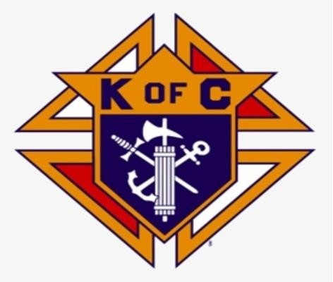Knightly News

# Council 2181

# DECEMBER 2024

**Grand Knight Roland LeBlanc**

The Knights of Columbus Council 2181 now serves the parishes of St Ambrose and Notre-Dame de L’ Assomption.

**Message from Grand Knight – Roland LeBlanc**

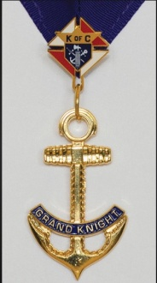 As we move into the last month of 2024, December brings with it the joy of Christmas that will soon be followed by the opportunities of a new year – 2025. Let us give thanks for all the blessings received and for the good health, the wonderful work our pastor Father Henry does to keep our faith alive at St. Ambrose Co Cathedral and the various volunteer groups that help out.

I take this opportunity to wish each and everyone of you a “Very Merry Christmas and a Prosperous New Year 2025.

Council 2181 has been busy with its own work and services to the Christian Community and our church. Let us not forget the less fortunate and homeless and keep them in our prayers this Christmas season.

**Youth Summer Camp Golf Tournament**

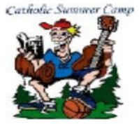Council 2181 held the annual Golf Tournament on October 10th with a shotgun start at 10am. The tournament was well attended. All proceeds will go in support of the St. Ambrose Youth Summer Camp. Last year’s tournament funded a donation of $3000 made in June to help with costs so kids could attend the camp. We hope to match our donations as of last year. We would like to thank Phil Mooney (902-749-6379) for all his efforts in making this event a success.

# COATS FOR KIDS PROGRAM

# coats.jpgCouncil 2181 again purchased 8 boxes (96 Coats) at a cost of $1380.00 to help ensure children are warm this winter. Mr. Josh Purdy from Schools Plus helped ensure that school principals, who had a list of students in need, were contacted and 48 coats were distributed within the Tri-County English schools. The other 48 coats were distributed by our Notre-Dame Roundtable Knights to CSAP schools. Grand Knight and Council 2181 would like to thank all volunteers especially our Tusket Knights and Josh from Schools Plus in carrying out this excellent work to see that the children are warm this winter,

**Operation Smile**

# Christmas clip.jpgOperation Smile delivers free, safe corrective surgery and continuing care to children wherever they live in the world. Brother Daniel Saulnier of Wedgeport does a great job in collecting bottles for recycling. If you would like to donate in cash or with bottles, please contact Brother Daniel at (902) 740-2098 or simply ask to have your bottles donated to Operation Smile at the Paper Chase Bottle Exchange

# Knights of Columbus Choir

The Knights Choir took part in this year’s Christmas concert “Night of Joy” on Dec 15th.

**Council Fundraisers**

# FIA clip.jpg The Knights of Columbus Breakfasts held in October and November were in support of St Ambrose wheelchair ramp railing replacement project. The profits were topped up to $1000.00. In addition, a takeout fundraiser was organized and an additional $1585.00 was raised. Council again rounded up the amount to an even S 3000.00 and a cheque given to Father Henry. We would like to thank all our parishioners for their kindness and generosity in supporting this project.

Council 2181 also made their annual donation of $1000 to the Tabitha Center in December. Brother Knights are once again assisting the Salvation Army with their Christmas Kettle Fundraising campaign. If you see a Knight at the Canadian Tire Store please stop and thank him for his service.

# Special Olympics

# The Annual Brother John Allan Boudreau Memorial Award was presented at their Annual Christmas Dinner. The Recipient was Miss Lisa Fitzgerald for her loyalty to her fellow Olympians. This award comes with a $50.00 cheque and her name will be engraved on the Memorial Plaque

# Update from Membership Director

FIA clip.jpg We are looking for men to join the order and have a satisfying experience of doing charity in our local community and the church. If you know of anyone that would be interested in joining, please see one of our brother knights either before or after Mass or contact Grand Knight Roland (902-988-0242) or Brother Roy (902-774-3043).

# For the Good of the Order

# Emblem.jpg

For the “Good of the Order” if you know of any brother knight or knights who are in

distress, sick, in the hospital or need our prayers, please get in touch with brother. Bill Carroll at (902) 749-3207, we will make every effort to visit and pray for them.