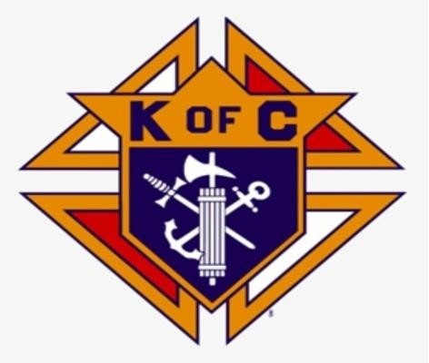
Knightly News
Council 2181
JUNE 2024
Grand Knight Roland LeBlanc

The Knights of Columbus Council 2181 now serves the parishes of St Ambrose and Notre-Dame de L’ Assomption.

Message from Grand Knight – Roland LeBlanc

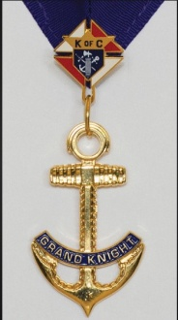
Summer is finally here; daylight is getting longer everyone is busy working their yards enjoying the sunshine and backyard BBQ’s and summer trips to see their loved ones. Council 2181 was busy in its own work and services to the Christian Community and our church. Let us not forget the less fortunate and homeless and keep them in our prayers. Have a safe summer.
Since our last newsletter, Council 2181has lost members (Brothers Chester Munroe, Pierre Doucette and Russell Frotten) due to various illness. We keep the families of our departed brother Knights in our prayers and may God grant them the strength to bear their loss.

Memorial Mass

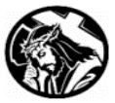
A memorial mass was held at St. Ambrose Co-Cathedral on May 15th at 6:30 pm for our deceased brother knights, led by our pastor Fr. Henry Solomenaars assisted by the honor guard and the choir. A total of 22 names were read and a candle was lit in their memory.
Following Mass, a coffee and apple crisp was served in the Jubilee room, there was a good turnout. Thank you for coming.

Pro-Life Tri-County Care Centre Support

Brother William Carroll once again is leading the Baby Bottle Fundraising Campaign this year, annual Baby Bottle Fundraiser started on Mother’s Day weekend, Sunday May12th and will conclude on Father’s Day Sunday June 16th. Many thanks to the parishioners for making this event a huge success.

Operation Smile

Operation Smile delivers free, safe corrective surgery and continuing care to children wherever they live in the world. Brother Daniel Saulnier of Wedgeport does a great job in collecting bottles for recycling. If you would like to donate in cash or with bottles, please contact Brother Daniel at (902) 740-2098 or simply ask to have your bottles donated to Operation Smile at the Paper Chase Bottle Exchange. A breakfast was held to raise funds and $ 600.00 was handed to this worthy cause by Council 2181.

Yarmouth Food Bank Support

Knights of Columbus are committed to helping end hunger through various programs – Council 2181 does this through our monthly food collection drive.
Members of our council are at the church on the first Sunday of every month before Masses, A total of $7000.00 and 650 lbs. of food was handed over to the Food Bank for the period of April, May and June 2024. We thank all our parishioners for their kind generosity and support to this worthy cause.

Parish Picnic
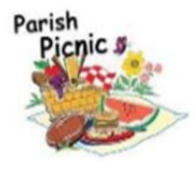
A parish picnic will be organized once again this year at Ellenwood Park. Mark the date in your calendar which is Sunday July 21. Further details will be provided in the church bulletin. We hope you come and enjoy the outdoors, hamburgers, hotdogs, chips and pop will be served. There will be games for kids and adults as well.

Salvation Army Christmas Campaign
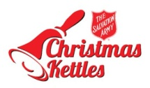
Knights of Columbus Council 2181 have assisted the Salvation Army in their Christmas Kettle Campaign. This past Christmas season was no exception. Over 26 days, 27 Knights volunteered 272 hours and collected $11,219.00 which will used to assist people in our community who need help. Salvation Army Captain Thomas Marsh expressed his gratitude to all who assisted in this year’s campaign. The Knights of Columbus look forward to helping again with the campaign next Christmas.

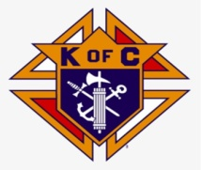
For the “Good of the Order” if you know of any brother knight or knights who are in
distress, sick, in the hospital or need our prayers, please get in touch with brother.
Bill Carroll at (902) 749-3207, we will make every effort to visit and pray for them.

Anniversaries
We are pleased to announce that Sir Knight Leeland Doucette and his wife Ella celebrated their 54 years of marriage on May 23. That is a wonderful occasion. May our Lord bless them and keep them together always. Congratulations.

